**Assignment Day 3 | 2nd December 2020**

**Parveen Kumar Rohilla**

**Question 1**

1. Create a blank file named "myfile"
2. First we open the terminal and type the command **cat > myfile** to create a new file.
3. After creating the file we will press **Ctrl+d** to save our file.

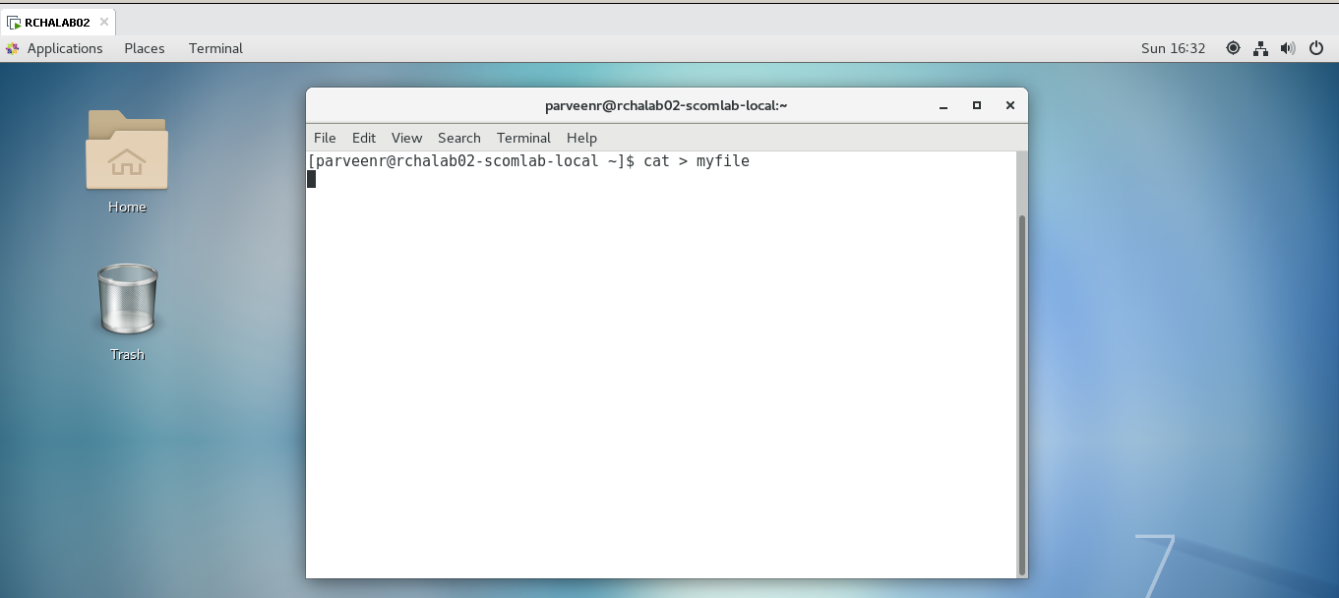

1. Now type **ls** command to verify our file is created or not.

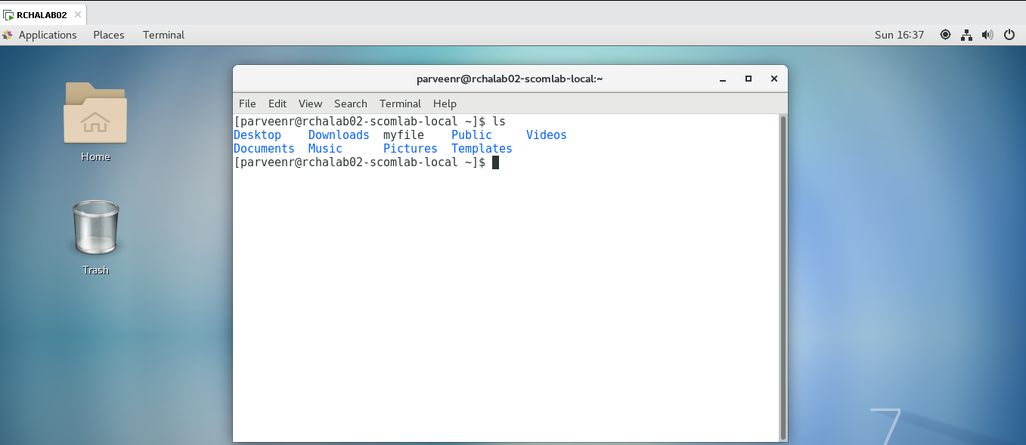

1. Open "myfile" in vi editor
2. Now we type **vi myfile** in terminal windows and then press enter to open this file in vi editor.

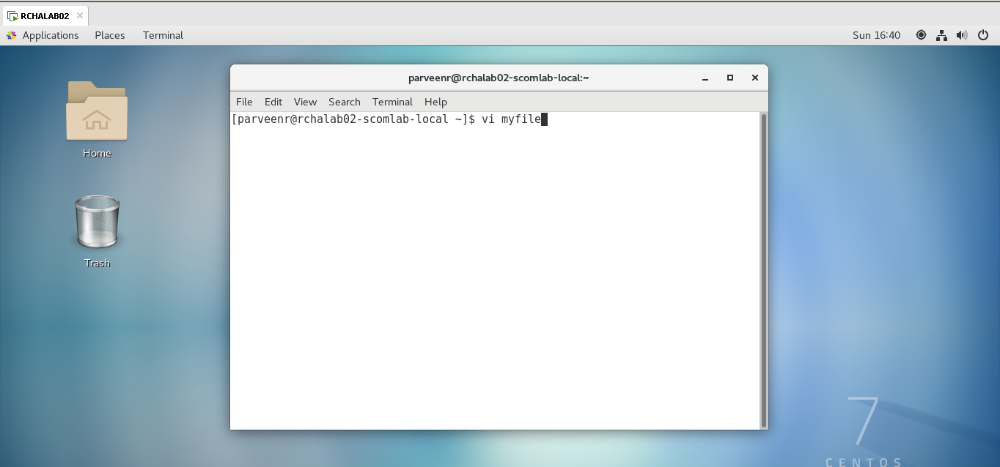

1. Write your name, address, email id, phone number and blood group in 5 different lines
2. Now we press i to enter in insert mode.
3. Now we type our name, address, email id, phone number and blood group in 5 different line.
4. Now press Esc key to enter in command mode, now we enter wq command to save our file and quit from vi editor.

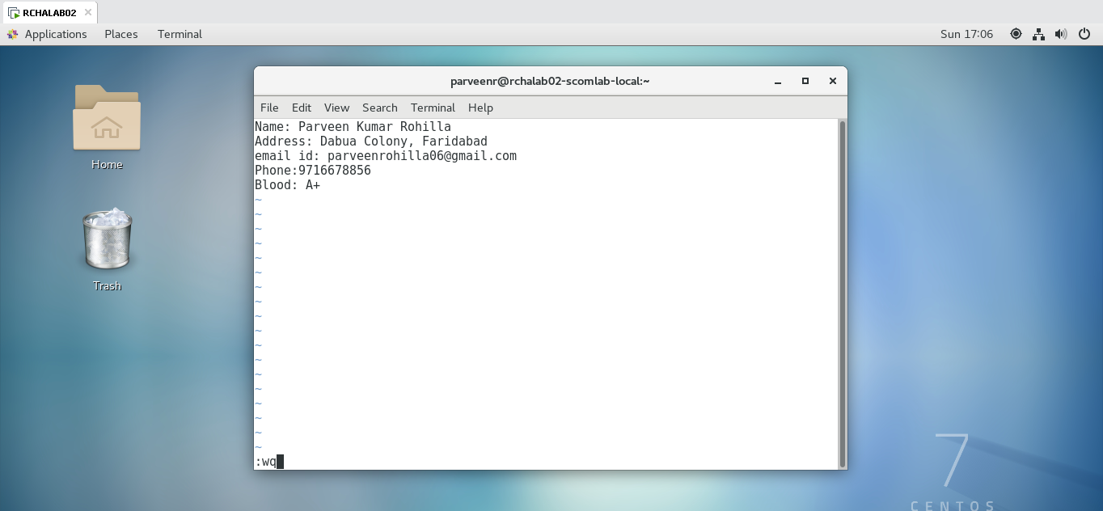

1. Build one single expression to see the line with your name and blood group in myfile
2. Since grep does not support the pipe symbol as the alternation operator, you need to use the escape character (backslash**\** ) to tell the grep command to treat the pipe differently.

**grep 'Name\|Address\|email\|Phone\|Blood' myfile**

